Brunch Menu
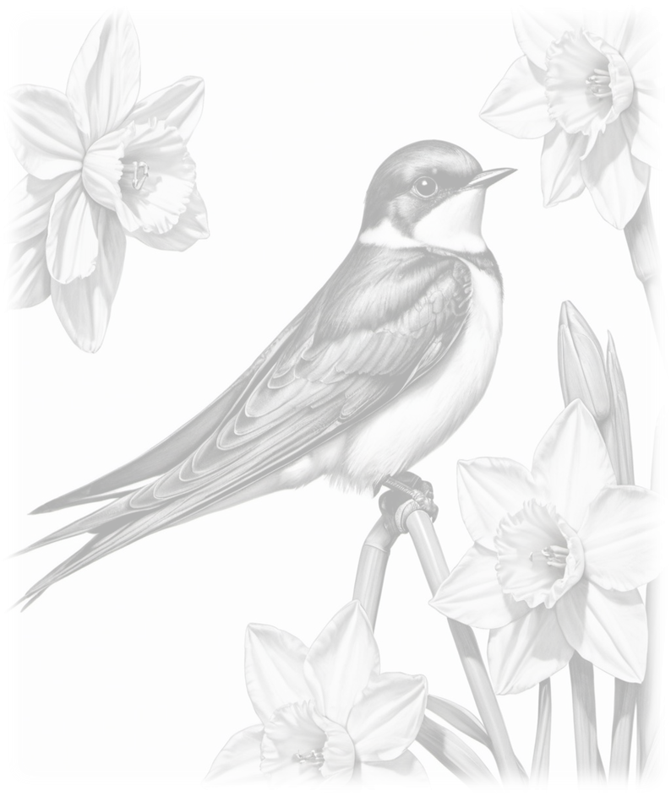
10:00 – 11:45AM
Brockhole Breakfast £13.00
Cumberland sausage, local thick cut bacon, fried egg, baked beans,
hashbrown, confit cherry tomatoes, wild mushrooms & sour dough toast

Bacon or Sausage Butty (GF*) £6.50
Local thick cut bacon or Cumberland sausage on a ciabatta bun

Breakfast Stack £9.50
Cumberland sausage whirl, American style cheese, egg,
hashbrown & Westmoreland chutney on a ciabatta bun

Avo & Hummus (V, VE*, GF*) £11.00
Sourdough toast with hummus, avocado, halloumi, chilli jam,
soft poached eggs, wilted spinach, shoots & black onion seeds

Hot-Smoked Salmon (GF*) £9.50
Hot smoked salmon, scrambled eggs, chives on sour dough toast

Waffles
Smoked streaky bacon and maple syrup £8.50
Berry compote, fresh berries & whipped cream £8.50

EXTRAS
Fried egg £1.00
Bacon (2 slices) £3.00
Cumberland sausage whirl £3.50
Toast (2 slices) and butter £2.75
Hashbrown £1.50
Baked beans £1.25
Please make us aware of any allergies or intolerances when ordering.
A full list of allergens is available on request.
V – Vegetarian; VE – Vegan; GF – Gluten Free
The * denotes that a dish may be altered to suit a particular
dietary requirement upon request

Brunch Menu
10:00 – 11:45AM
Brockhole Breakfast £13.00
Cumberland sausage, local thick cut bacon, fried egg, baked beans,
hashbrown, confit cherry tomatoes, wild mushrooms & sour dough toast

Bacon or Sausage Butty (GF*) £6.50
Local thick cut bacon or Cumberland sausage on a ciabatta bun

Breakfast Stack £9.50
Cumberland sausage whirl, American style cheese, egg,
hashbrown & Westmoreland chutney on a ciabatta bun

Avo & Hummus (V, VE*, GF*) £11.00
Sourdough toast with hummus, avocado, halloumi, chilli jam,
soft poached eggs, wilted spinach, shoots & black onion seeds

Hot-Smoked Salmon (GF*) £9.50
Hot smoked salmon, scrambled eggs, chives on sour dough toast

Waffles
Smoked streaky bacon and maple syrup £8.50
Berry compote, fresh berries & whipped cream £8.50

EXTRAS
Fried egg £1.00
Bacon (2 slices) £3.00
Cumberland sausage whirl £3.50
Toast (2 slices) and butter £2.75
Hashbrown £1.50
Baked beans £1.25
Please make us aware of any allergies or intolerances when ordering.
A full list of allergens is available on request.
V – Vegetarian; VE – Vegan; GF – Gluten Free
The * denotes that a dish may be altered to suit a particular
dietary requirement upon request

Drinks Menu
HOT DRINKS
Espresso (Double) £3.00
Americano £3.00
Flat White £3.30
Latte £3.30
Cappuccino £3.30
Mocha £3.50
Decaffeinated coffee available
for all drinks
Hot Chocolate £3.50
Gourmet* Hot Chocolate £4.50
Babyccino £2.00
Children’s Hot Chocolate £2.50
Children’s Gourmet* Hot
Chocolate £3.50
(*With Cream & marshmallows)
EXTRAS
Shot of coffee £1.35
Flavoured syrup £0.50
(Vanilla, Caramel, Hazelnut
Gingerbread)
Oat/Soya milk £0.50
Flake £0.70
Cream & marshmallows £1.00
TWINING’S TEA
English Breakfast £2.60
Decaffeinated £2.60
Earl Grey £2.80
Red Bush £2.80
Peppermint £2.80
Green Tea £2.80
SOFT DRINKS
Coca Cola £2.95
Diet Coke £2.75
Fresh Apple/Orange £2.75
CAWSTON PRESS
Rhubarb & Apple £2.95
Ginger Beer £2.95
Elderflower & Lemon £2.95
SAN PELLEGRINO
Limonata £2.95
Aranciata £2.95
HARROGATE MINERAL WATER
Still (330ml) £2.50
Still (750ml) £3.90
Sparkling (330ml) £2.50
Sparkling (750ml) £3.90
CHILDREN’S DRINKS
Juice Cartons
Orange £1.80
Apple £1.80
Ribena £1.80
Glass of milk £2.00

Cakes & Sweet Treats
We always have a range of cakes/traybakes on offer, as well as freshly baked scones & tubs of English Lakes ice-cream.
For those of you with a sweet tooth, please look at our cake display cabinet, or ask your server for the choice on offer today!

Drinks Menu
HOT DRINKS
Espresso (Double) £3.00
Americano £3.00
Flat White £3.30
Latte £3.30
Cappuccino £3.30
Mocha £3.50
Decaffeinated coffee available
for all drinks
Hot Chocolate £3.50
Gourmet* Hot Chocolate £4.50
Babyccino £2.00
Children’s Hot Chocolate £2.50
Children’s Gourmet* Hot
Chocolate £3.50
(*With Cream & marshmallows)
EXTRAS
Shot of coffee £1.35
Flavoured syrup £0.50
(Vanilla, Caramel, Hazelnut
Gingerbread)
Oat/Soya milk £0.50
Flake £0.70
Cream & marshmallows £1.00
TWINING’S TEA
English Breakfast £2.60
Decaffeinated £2.60
Earl Grey £2.80
Red Bush £2.80
Peppermint £2.80
Green Tea £2.80
SOFT DRINKS
Coca Cola £2.95
Diet Coke £2.75
Fresh Apple/Orange £2.75
CAWSTON PRESS
Rhubarb & Apple £2.95
Ginger Beer £2.95
Elderflower & Lemon £2.95
SAN PELLEGRINO
Limonata £2.95
Aranciata £2.95
HARROGATE MINERAL WATER
Still (330ml) £2.50
Still (750ml) £3.90
Sparkling (330ml) £2.50
Sparkling (750ml) £3.90
CHILDREN’S DRINKS
Juice Cartons
Orange £1.80
Apple £1.80
Ribena £1.80
Glass of milk £2.00

Cakes & Sweet Treats
We always have a range of cakes/traybakes on offer, as well as freshly baked scones & tubs of English Lakes ice-cream.
For those of you with a sweet tooth, please look at our cake display cabinet, or ask your server for the choice on offer today!

