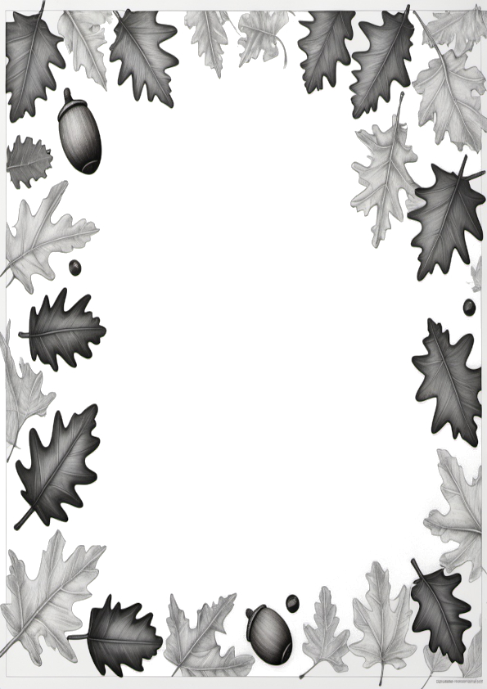
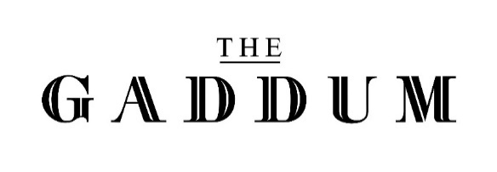

Scan in the OrderMe App
Breakfast
Available 10:00 – 11:30
venue code: A7J2LG
Brockhole Breakfast £13.00
Cumberland sausage, local thick cut bacon, fried egg, baked beans,
hashbrown, confit cherry tomatoes, field mushrooms & sourdough toast
Bacon or Sausage Butty £6.50
Local thick cut bacon or Cumberland sausage on a sourdough bun
Veggie Butty (V, VE*) £6.50
Halloumi, mushrooms & fresh baby leaf spinach on a sourdough bun
Toasted Banana Bread £7.00
Served with whipped cream, toffee sauce and dried bananas
Brunch
Available 10:00 – 15:30
Brockhole Breakfast Stack £9.50
Cumberland sausage patty, American style cheese, fried egg & hashbrown on a sourdough bun
Chorizo Hash £11.50
Potato hash with chorizo, cherry tomatoes, roasted red peppers, topped with chives and a fried egg
Veggie Hash (V, VE*) £9.50
Potato hash with artichokes, cherry tomatoes, roasted red peppers, mushrooms, topped with chives and a fried egg
Lunch
Available 12:00 – 15:30
Soup of the Day (VE*) £6.50
Freshly prepared soup served with toasted sourdough & butter
Hog Roast Bun £14.00
Roast porchetta, sage stuffing, caramelised onions, apple butter on a brioche bun with a side of gravy and fries
Cumbrian Venison Burger £14.00
Cartmel Valley venison burger on a brioche bun, fig chutney, slaw, applewood smoked cheddar, skinny fries
Smoked Haddock Chowder £10.00
Classic homemade chowder served with toasted sourdough & butter
Squash & Butter Bean Stew (VE) £12.00
Harissa spiced squash & butter bean stew served with toasted sourdough, mint & coconut yoghurt & fresh coriander
Sarnies
SERVED ON CIABATTA WITH SALAD GARNISH
Available 12:00 – 15:30
Rare Roast Beef £8.00
Slow cooked Cumbrian beef, rocket, caramelied onions, French mayonnaise
Coronation Chicken £7.50
Mango chutney, gem lettuce
Cheese & Chutney (V) £7.50
Local cheddar cheese, Brockhole tomato chutney, rocket
Egg & Cress (V) £6.50
Free-range egg and mayonnaise topped with fresh watercress
Sides
Salted fries (VE) £3.50
Rosemary, parmesan & truffle fries (V) £4.50
Cup of home-made soup (VE) £3.50
Please make us aware of any allergies or intolerances when ordering. An allergen menu is available on request
V – Vegetarian; VE – Vegan.
The * denotes that a dish may need to be altered
to suit a particular dietary
requirement upon request.
DRINKS MENU

Hot Drinks
Espresso (Double) £3.00
Americano £3.00
Flat White £3.30
Latte £3.30
Cappuccino £3.30
Mocha £3.50
Decaffeinated coffee available for all drinks
Hot Chocolate £3.50
Gourmet* Hot Chocolate £4.50
Babyccino £2.00
Children’s Hot Chocolate £2.50
Children’s Gourmet* Hot Chocolate £3.50
(*With Cream & marshmallows)
Extras
Shot of coffee £1.35
Flavoured syrup £0.50
(Vanilla, Caramel, Hazelnut, Gingerbread)
Oat/Soya milk £0.50
Flake £0.70
Cream & marshmallows £1.00
Twining’s Tea
English Breakfast £2.60
Decaffeinated £2.60
Earl Grey £2.80
Red Bush £2.80
Peppermint £2.80
Green Tea £2.80
SOFT DRINKS
Coca Cola £2.95
Diet Coke £2.75
Fresh Apple/Orange £2.75
Cawston Press
Rhubarb & Apple £2.95
Ginger Beer £2.95
Elderflower & Lemon £2.95
San Pellegrino
Limonata £2.95
Aranciata £2.95
Harrogate Mineral Water
Still (750ml/330ml) £3.90/£2.50
Sparkling (750ml/330ml) £3.90/£2.50
Children’s Drinks
Juice Cartons
Orange £1.80
Apple £1.80
Ribena £1.80
Glass of milk £2.00

Milkshakes £4.50
Chocolate
Vanilla
Strawberry
Bubble Gum
Banana

Local Craft Beer/Lager
Served from 11am

Bowness Bay Brewery (All 500ml bottles)
Swan Free Craft Lager (0.5%) £6.50
Hawkshead Brewery (All draft)
Half Pint Pint
Helles Lager (4.3%) £3.50 £6.00
Brockhole Pale Ale (4%) £3.50 £6.00
Celtic Marches Cider (4.6%) £3.50 £6.00

WinE
Served from 11am
Prosecco (200ml) £8.75
House White (187ml) £7.75
House Red (187ml) £7.75
House Rosé (187ml) £7.75

For our full selection of wines and spirits ask for our Bar and Wine menu

Cakes & Sweet Treats
We always have a range of cakes/traybakes on offer, as well as freshly baked scones & tubs of English Lakes ice-cream.
For those of you with a sweet tooth, please look at our cake display cabinet, or ask your server for the choice on offer today!

