CHILDREN`S MENU
Brunch served 10am – 11:30am
Cumberland Sausage Butty £6.50
Bacon Butty £6.50
Children’s Breakfast £5.50
bacon (1 slice), fried egg, beans, a slice of toast
Brown/White Toast with Butter £2.75
add beans £1.25
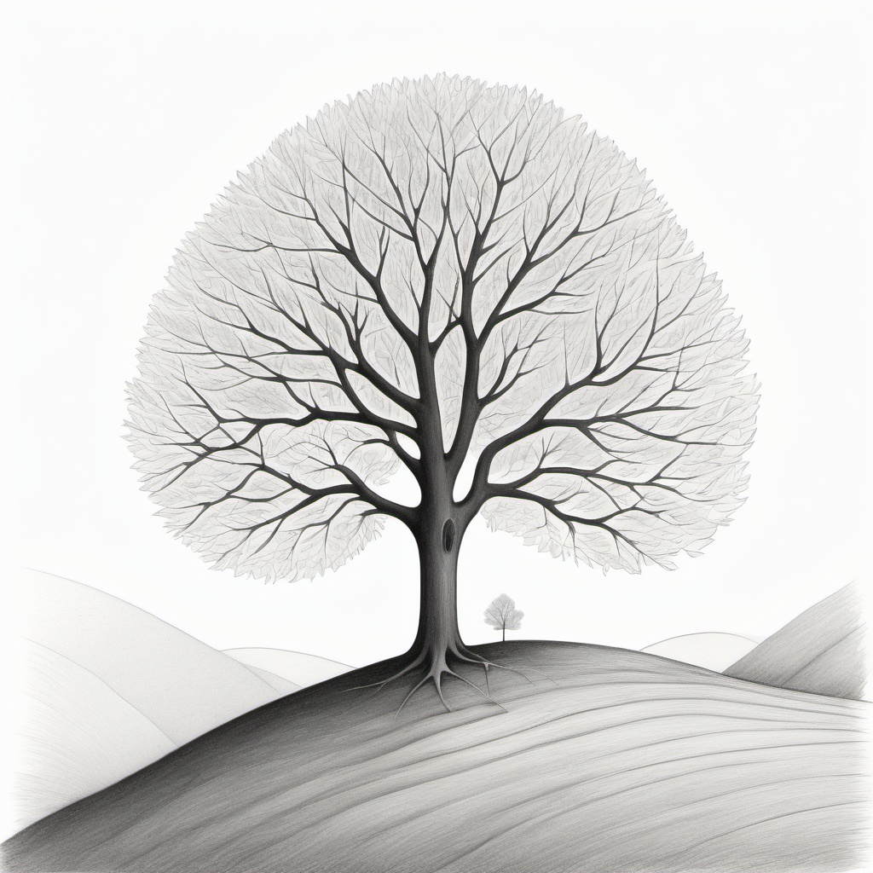
Toasted Fruit Teacake with Butter £2.95

Lunch served 12pm – 3:30pm
MAIN MEALS
Homemade Soup of the Day £4.00
A cup of soup served with bread & butter
Cumberland Sausage, Fries & Peas £6.00
Mac & Cheese (V) £4.50
Cheese or Ham Sandwich £4.00
Served with crisps

SWEET TREATS
Small tub of English Lakes ice-cream £3.50
Selection of homemade cakes from £2.85

